SUPERVISION
Date / time: 09/10/2025

Main issues discussed
- Ethics Application vs Research Proposal
- specific suggestions for the Gantt chart
- readability and audience
- Structure and Essential Content of the Proposal
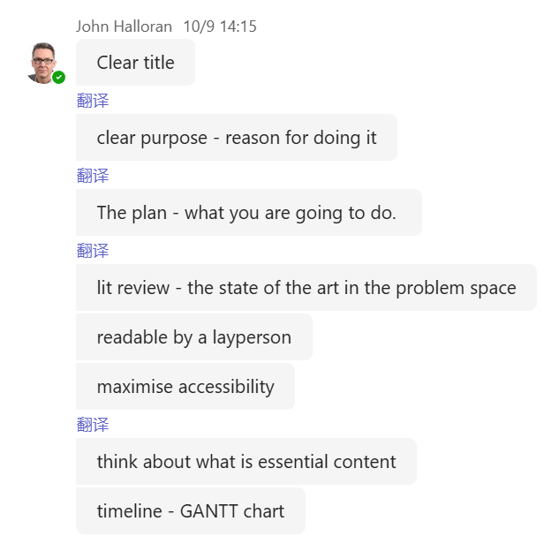

Work shown
the presentation by my supervisor, John Halloran
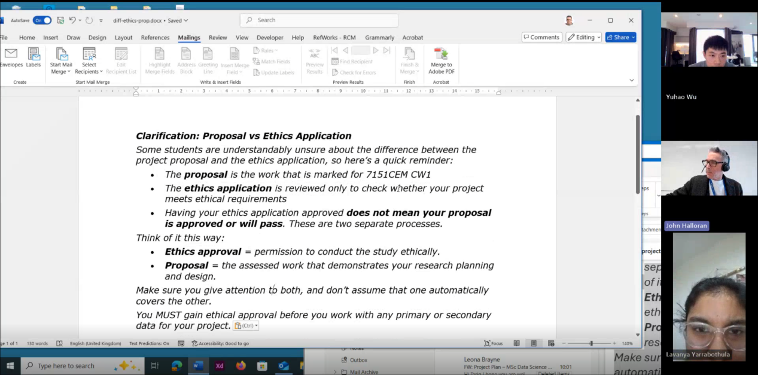

Questions asked; how questions were answered
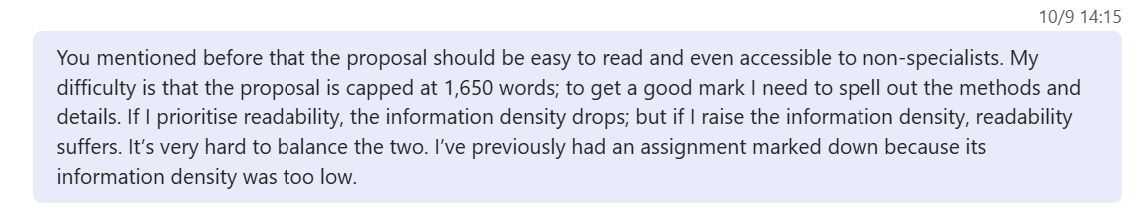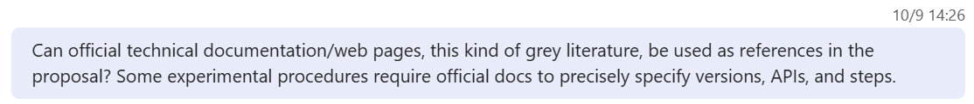
Answer
- It really is a trade-off between readability and information density. All professional researchers have to maximise the accessibility of their work, but it is precisely because this is a Master’s-level assignment that it becomes challenging.
- It can be used, but not too much. Peer review means that experts help to check and safeguard the quality of each other’s work; therefore, papers in academic journals are particularly important.
The value of grey literature lies in the fact that it often raises important issues earlier and can inspire research questions.

Email
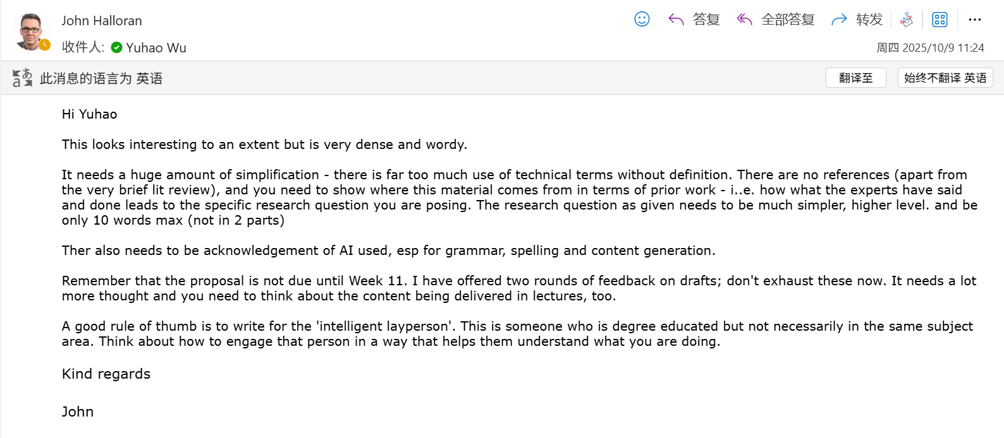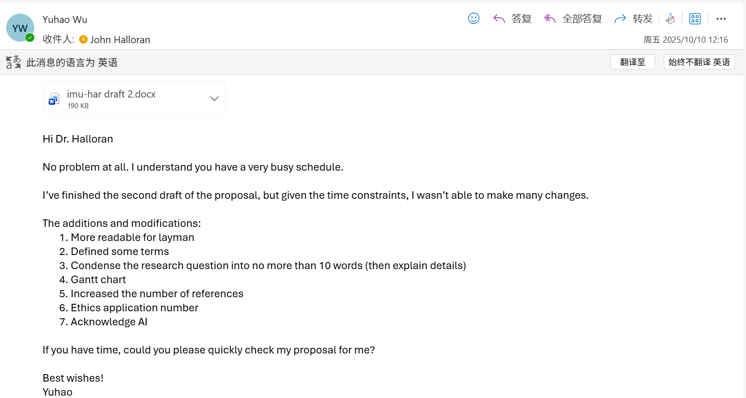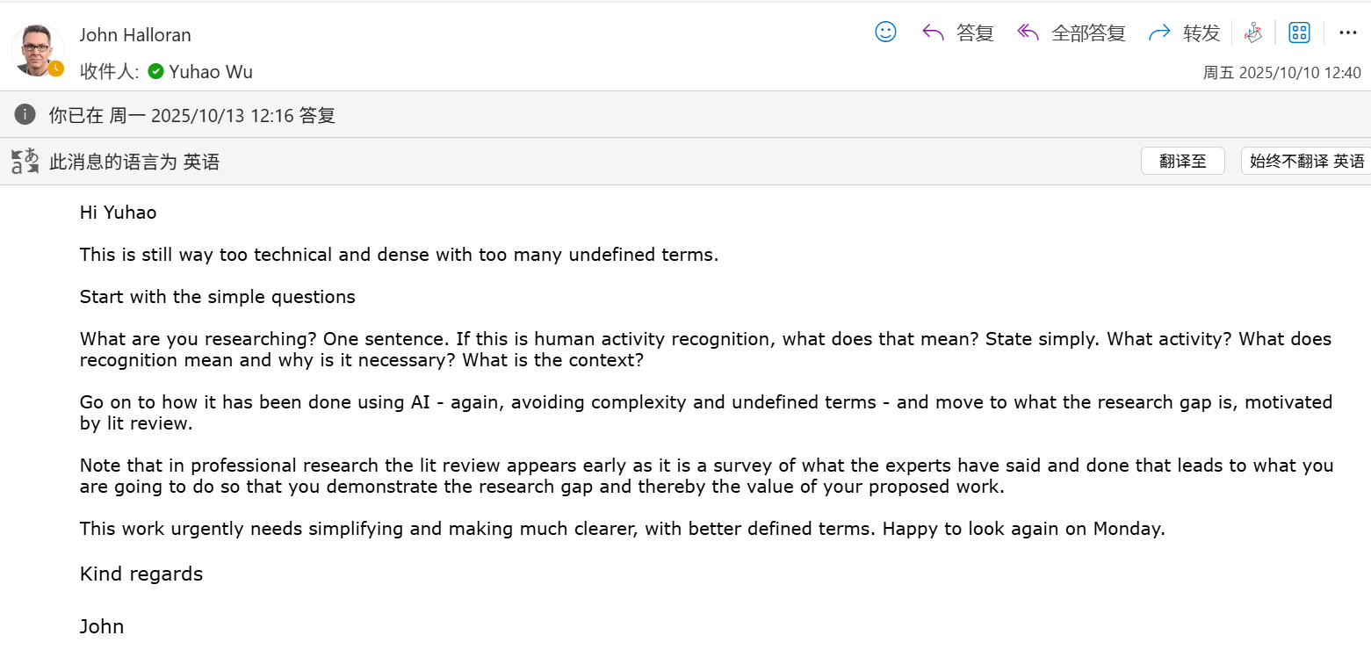

Computing Project
WORK DONE
1. Complete all preprocessing for the RealWorld dataset.
2. Revise the proposal under the guidance of my supervisor, Halloran.
3. Look for alternative datasets that are not from Kaggle or the UCI Machine Learning Repository (LaRa Dataset).

Issues and challenges
The proposal is still too dense, and its readability is not high enough.

Actions for next week
1. Improve the readability of the proposal by defining and explaining key terms.
2. Train and test several baseline models on the fully preprocessed RealWorld dataset to see the results.

Evidence
https://livecoventryac-my.sharepoint.com/:v:/g/personal/aa1910_coventry_ac_uk/EVjgsFUPBQZJnPAw5G4eWGAB-TAN7NLLjgToTqWwDAIsnw

Backup link (in case the original link expires)
Part 1
https://livecoventryac-my.sharepoint.com/:v:/g/personal/wuy176_uni_coventry_ac_uk/Ecf83zfoTZxIghETjmGzrigB7qqzLXU-1EreJyHyeY9ojw?e=9OM2Hu&nav=eyJyZWZlcnJhbEluZm8iOnsicmVmZXJyYWxBcHAiOiJTdHJlYW1XZWJBcHAiLCJyZWZlcnJhbFZpZXciOiJTaGFyZURpYWxvZy1MaW5rIiwicmVmZXJyYWxBcHBQbGF0Zm9ybSI6IldlYiIsInJlZmVycmFsTW9kZSI6InZpZXcifX0%3D

Part 2
https://livecoventryac-my.sharepoint.com/:v:/g/personal/wuy176_uni_coventry_ac_uk/ET0Ffy3wAg5FoigaiJZDp_wBv6oOE2N7DIrJ_vhfgLvGWw?e=oUuTrq&nav=eyJyZWZlcnJhbEluZm8iOnsicmVmZXJyYWxBcHAiOiJTdHJlYW1XZWJBcHAiLCJyZWZlcnJhbFZpZXciOiJTaGFyZURpYWxvZy1MaW5rIiwicmVmZXJyYWxBcHBQbGF0Zm9ybSI6IldlYiIsInJlZmVycmFsTW9kZSI6InZpZXcifX0%3D

